Lower Caribbean Bible College

Administrative System

Design Document

Version 1.0

© Alpha Solutions Inc.

Table of Contents

Data Design………………………………………….……………………………….3
- Data Elements…………………………….………………………………….3
- Database Schema……………………….……………………………………3

Architecture Design………………………….………………………………………4
- Scope………………………………………………………………………....4
- Programming Language and Software Constraints…………..………………4
- Reuse Analysis and Buy vs. Build Decisions…………….….……………….4
- Portability…………………………………………….………………………4
- Memory Management…………………………….………………………….4
- Error Handling……………………………………………….……………....4
- Security………………………………………………….…………………...4
- Installation……………………………………………………………………5

Interface Design………………………………………….…………………………..6
- Human Interfaces …………………………….……………………………...6
- Data Flow Diagram……………….……………………………….................7

Procedural Design……………………………………………………………….…..9
- Custom Classes……………………………………………………….……..9
- User Defined Functions…………………………………………….……….9
- Flow Chart……………………………………………………….………….10

DATA DESIGN

Data Elements

After analyzing the requirements and specifications documents the following data elements were deemed to be essential to the system:
- Receipt – Recording of a payment for goods or services.
- Items Purchasable – Item that can be placed on a receipt.
- Lecturer – lectures teach courses.
- Departments – Departments contain courses.
- Qualifications – Qualifications obtainable at Lower Caribbean Bible College.
- Grade Point – Grade Point Scheme
- Course – A class that a student can register for and that belongs to a department.
- Course Taken – A course that a student has completed.
- Class Schedule – Information about the meeting times of a particular course.
- Advisor – Individual advising a student.
- Applicant – Someone who has submitted a completed registration form but has not been approved.
- Student – An individual who has completed an application form and is allowed to register for courses.
- Personal Information – Common Information shared by Students and Applicants.

Database Schema

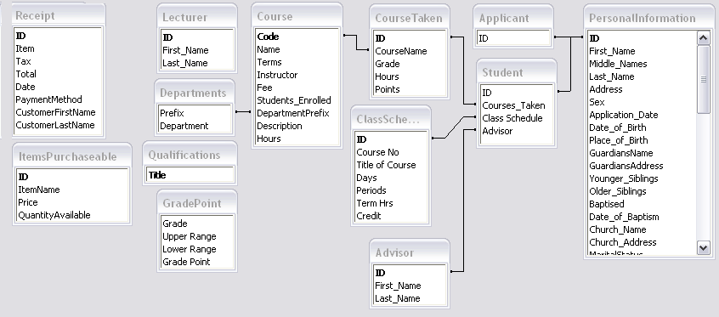
Database Schema

The above diagram is an Idealization of the database schema. Due to the way the DataGridView acquires information from the database the current version of the program contains an un normalized database which has reduced time programming. Future versions of the software will implement the above schema.
ARCHITECTURE DESIGN

Scope

- System Objectives:
The system is required to simplify a set of commonly performed tasks by the Lower Caribbean Bible College. These tasks include but are not limited to Generating Reports, Printing receipts and Updating student information.

- Design Constraints and Limitations:
The system will require the .NET 2.0 runtime to be installed. Only one user can access a table in the database at a time.

Programming Language and Software Constraints

C++/CLI was chosen for the project because of the group’s familiarity with C++ and .NET robust class library and its WinForms design environment. C++/CLI is essentially C++ with extensions to access the .NET platform. It adds many features to C++ that would otherwise require the use of 3rd party development libraries such as boost. For example C++/CLI adds garbage collection, reflection and regular expressions to C++.

Reuse Analysis and Buy vs. Build Decisions

The .NET 2.0 class libraries have the majority of the features required to implement the program. .NET is lacks in easily printing the data in the tables so for this freely available code will be utilized. Using a pre made printing library is much easier than building one from scratch.

Portability

The system is limited to the Microsoft Windows Operating system capable of installing .NET 2.0 or other implementations of the .NET 2.0 runtime such as mono on Linux. Other .NET 2.0 implementations will not be tested.

Memory Management

This is taken care of by the .NET garbage collector.

Error Handling

The system uses a mixture of exceptions and function return values to indicate errors. Exceptions are presented to the user via message boxes.

Security
User level passwords will be required to access specific tables and fields in the database.
Personal information such as grades and criminal history will require an administrator password.

Installation

Null Soft Installer system will be utilized for installation. The installer should be capable of installing the .NET 2.0 runtime if it not present. The uninstaller should remove all files and registry entries.
INTERFACE DESIGN

Human Interface

The user will be required to interact with tables in a database; an ideal solution to this problem is to utilize DataGridViews which are specially designed to display information in a tabular form. Additionally ListView controls will be used to prevent the user from having to scroll horizontally which is considered annoying. When DataGridViews and ListViews are used in conjunction with each other this is called a panel.

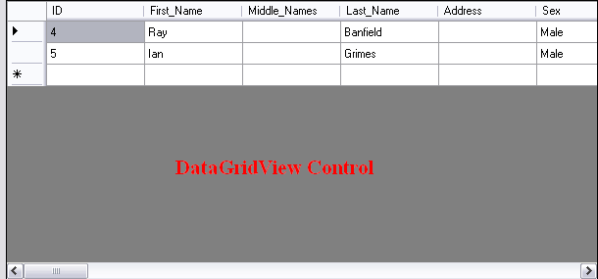
DataGridView Control

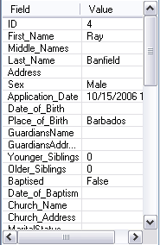
ListView Control

The ListView control eliminates horizontal scrolling by displaying the information for a single record top down rather than left to right.

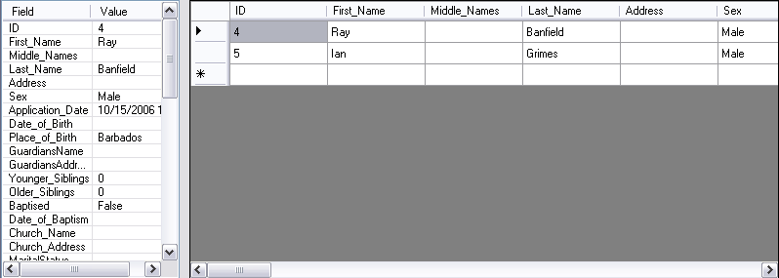
DataGridView and ListView Control together called a Panel.

Data Flow Diagram

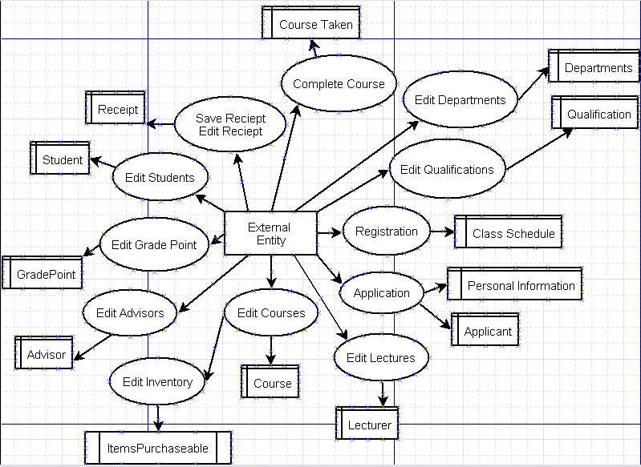
Data Flow Diagram emphasis on Tables
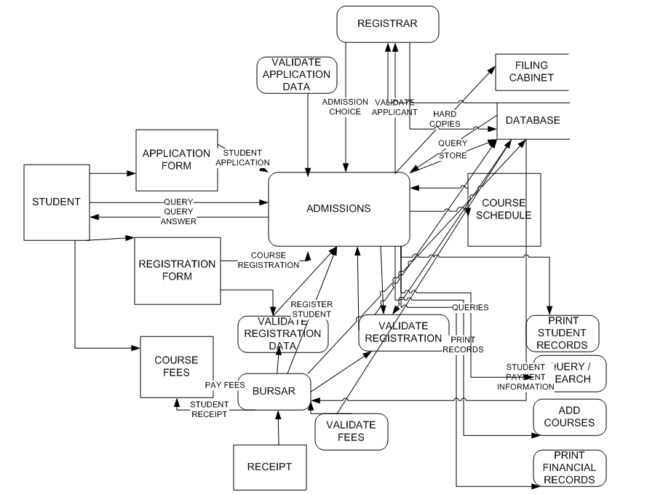
Data Flow Diagram Emphasis on Validation
PROCEDURAL DESIGN

Custom Classes

DataAccessClass: Responsible for all interaction with the database.
- Connect: Connect to the database.
- Close: Close the connection.
- Update: Save changes.
- Get Tables: Get a list of the tables in the database.
- Get Table: Get the schema associated with a table and all of its records.
- Delete Row: Delete a record.
- Get Columns: Get a list of the columns.
- Get Rows: Get a list of the records.

DataGridViewPrinter: Draws the contents of a DataGridView to a graphics device.
- DrawHeader: Draws the DataGridView header.
- DrawRows: Draws the rows of the DataGridView.

User defined Functions

Printing
- PrintHeader: Prints the Lower Caribbean Bible College Header at the top of a printable page.

Flow Chart
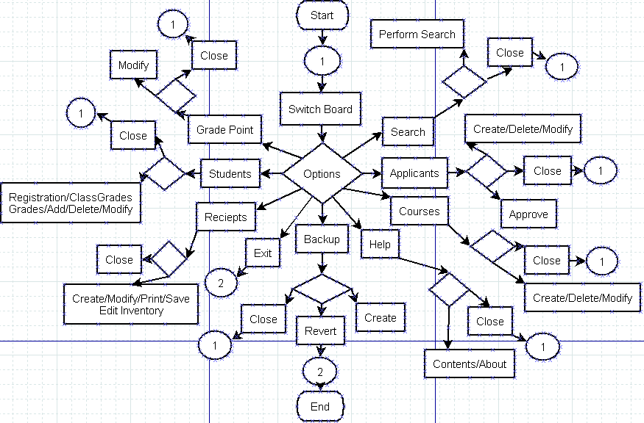
LCBCAdminSystem Flow Chart

Due to space constraints input symbols have been omitted.

© Alpha Solutions Inc.

